PRINCIPLE OF SOFTWARE ENGINEERING
PRINCIPLE OF SOFTWARE ENGINEERING 1
Introduction 1
SDG 4: Quality Education 2
The SDLC Applied to a Quality Education (SDG 4) 3
THE SYSTEM ARCHITECTURE DIAGRAM 8
List of Functional and non-Functional Requirement For Quality Education (SDGs4) 11
How I derived the components 15

Abstract

This project focuses on the design and development of a mobile application that supports Sustainable Development Goal 4 (SDG 4): Quality Education. The application aims to provide learners with easy access to educational resources, personalized learning paths, and user-friendly learning tools. The system allows users to register, login. access learning materials, and manage their profiles. The project follows the Software Development Life Cycle (SDLC), including requirements gathering, planning, design, development, testing, deployment, and maintenance. Functional and non- functional requirements were identified to ensure the application is efficient, secure, reliable, and accessible. The proposed solution seeks to enhance learning opportunities, promote educational inclusion, and contribute to the achievement of quality education
for all.

Introduction
Sustainable Development Goal 4 (SDG 4) aims to ensure inclusive and equitable quality education and promote lifelong learning opportunities for all. Technology can play an important role in improving access to education and learning resources,
This project focuses on developing a mobile application that supports quality education by providing users with access to learning materials, personalized learning features, and educational resources. The application is designed using the Software Development Life Cycle(SDLC) to ensure it is functional, secure, and user-friendly

SDG 4: Quality Education

Sustainable Development Goal 4 (SDG 4): Quality Education aims to ensure inclusive and equitable quality education and promote lifelong learning opportunities for all.

Objectives of SDG 4
Provide free, equitable, and quality primary and secondary education.
Ensure equal access to affordable technical, vocational, and higher education.
Eliminate gender disparities and ensure equal access for vulnerable groups.
Increase the number of people with relevant skills for employment and entrepreneurship.
Improve literacy and numeracy among young people and adults.
Build safe, inclusive, and effective learning environments.

Why SDG 4 is Important
Reduces poverty and inequality.
Promotes economic growth and decent work.
Improves health and well-being.
Encourages innovation and sustainable development.
Helps create peaceful and inclusive societies.

Examples of Actions Supporting SDG 4
Building and equipping schools.
Training and supporting teachers.
Providing scholarships and educational materials.
Expanding access to digital learning technologies.
Promoting inclusive education for girls and children with disabilities.
Goal Statement:
Ensure inclusive and equitable quality education and promote lifelong learning opportunities for all. SDLC for SDG 4: Quality Education

The SDLC Applied to a Quality Education (SDG 4)
Quality Education, the System Development Life Cycle (SDLC) can be used to develop an educational system (such as an e-learning platform or school management system) that supports quality education.

1. Planning
Identify educational problems and needs.
Define objectives, such as improving access to quality learning materials.
Determine resources, budget, and stakeholders (students, teachers, schools, and government).

2. Requirements Analysis
Gather requirements from users (students, teachers, administrators).
Identify features needed, such as:
Online classes
Digital libraries
Student records
Assignment and examination systems

3. System Design
Create the system architecture and interface.
Design databases for storing student and teacher information.
Plan security measures and accessibility features.

4. Development (Implementation)
Build the educational platform or software.
Program features such as user accounts, learning modules, and assessment tools.
Integrate multimedia content and communication tools.

5. Testing
Test the system for errors and usability.
Ensure all functions work correctly.
Verify that the platform is secure and accessible to all users.

6. Deployment
Launch the system in schools or educational institutions.
Train teachers and students on how to use it.
Provide user guides and technical support.

7. Maintenance
Update educational content regularly.
Fix bugs and improve performance.
Add new features based on user feedback and changing educational needs.

Example Application
System: Online learning management system (LMS)

SDLC phase | Activities for SDG 4
PLANNING | identify needs for digital learning
ANALYSIS | Gathering requirements from students and Teachers
DESIGN | Creating user interface and database
DEVELOPMENT | Build the LMS platform
TESTING | Check functionality and security
DEPLOYMENT | Implement in schools and train users
MAINTENANCE | Update content and improve the system

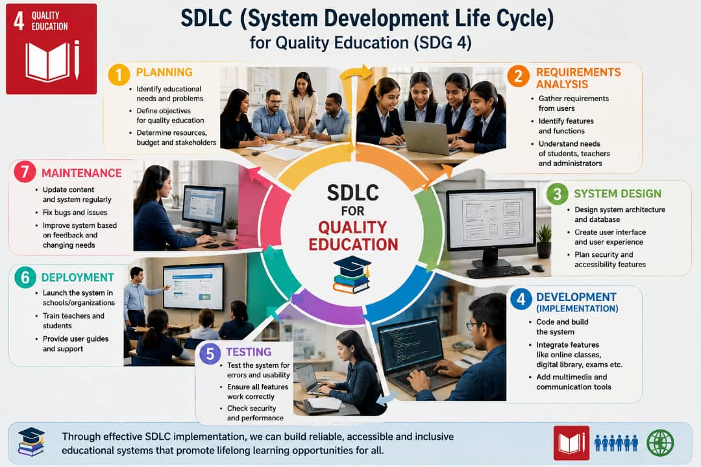

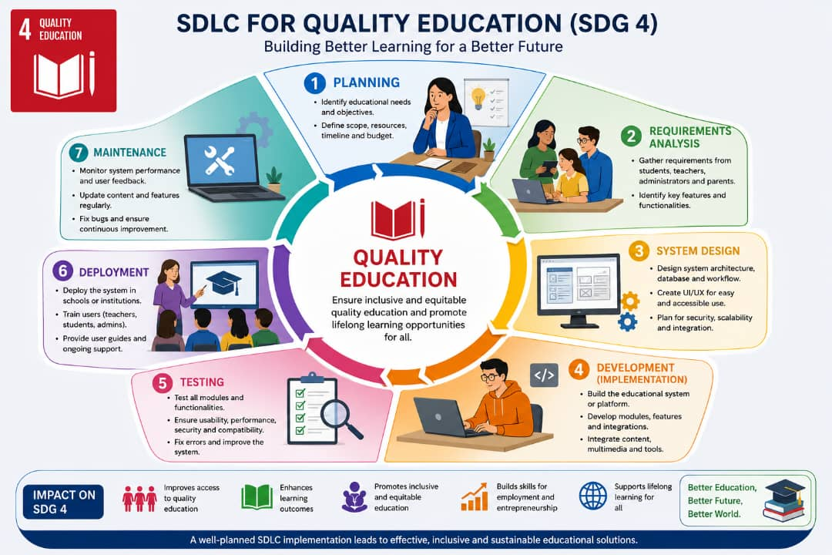

THE SYSTEM ARCHITECTURE DIAGRAM

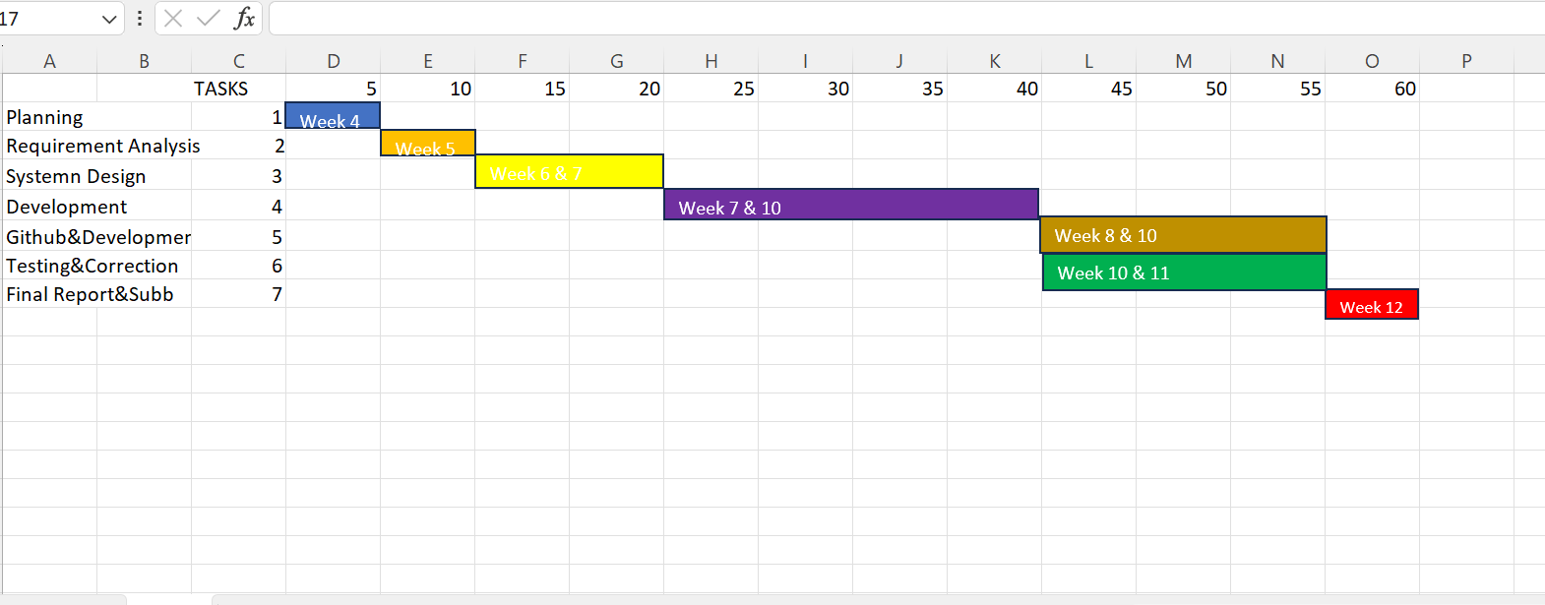

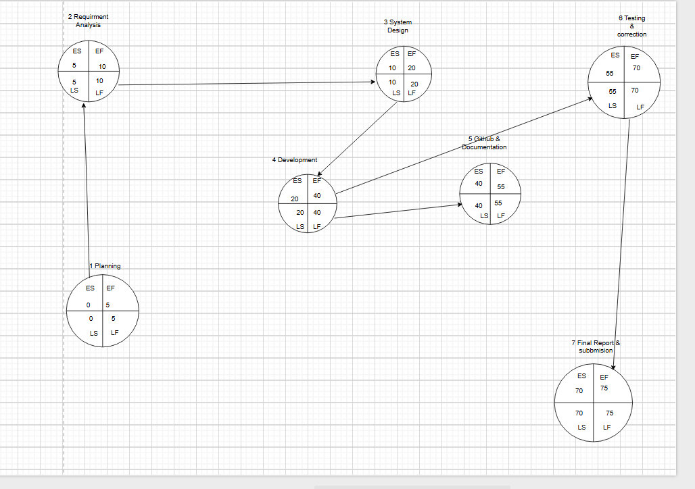

ID | Main Phase/Taskes | Duration (days/weeks) | Dependencies
1 | Planning | Week 4 (5 days) | –
2 | Requirement analysis | Week 5 (5 days) | 1
3 | System Design | Week 6&7(10 days) | 2
4 | Development | Week 7-10 (20 days) | 2&3
5 | Guithub & Documentation | Week 8-10 (15days) | 3&4
6 | Testing & Correction | Week 10 & 11 (10 days) | 4
7 | Final Report & Submission | Week 12 (5 days) | 4,5,6

List of Functional and non-Functional Requirement For Quality Education (SDGs4)
TYPE | REQUIREMENT
Functional | User can register /User Registration
Functional | User Login
Functional | Access Learning materials
Functional | User Profile
Functional | Access Personalized Learning Paths.

TYPE | REQUIREMENT
Non-Functional | App must load quickly
Non-Functional | Data must be secure
Non-Functional | App should support Android devices and other operating systems.

UML DIAGRAM FOR (SDGs 4)

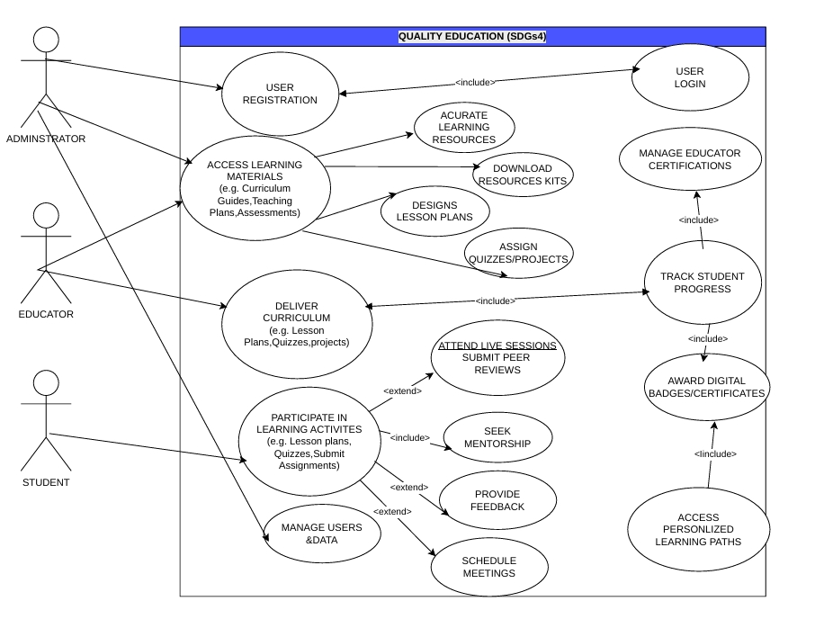

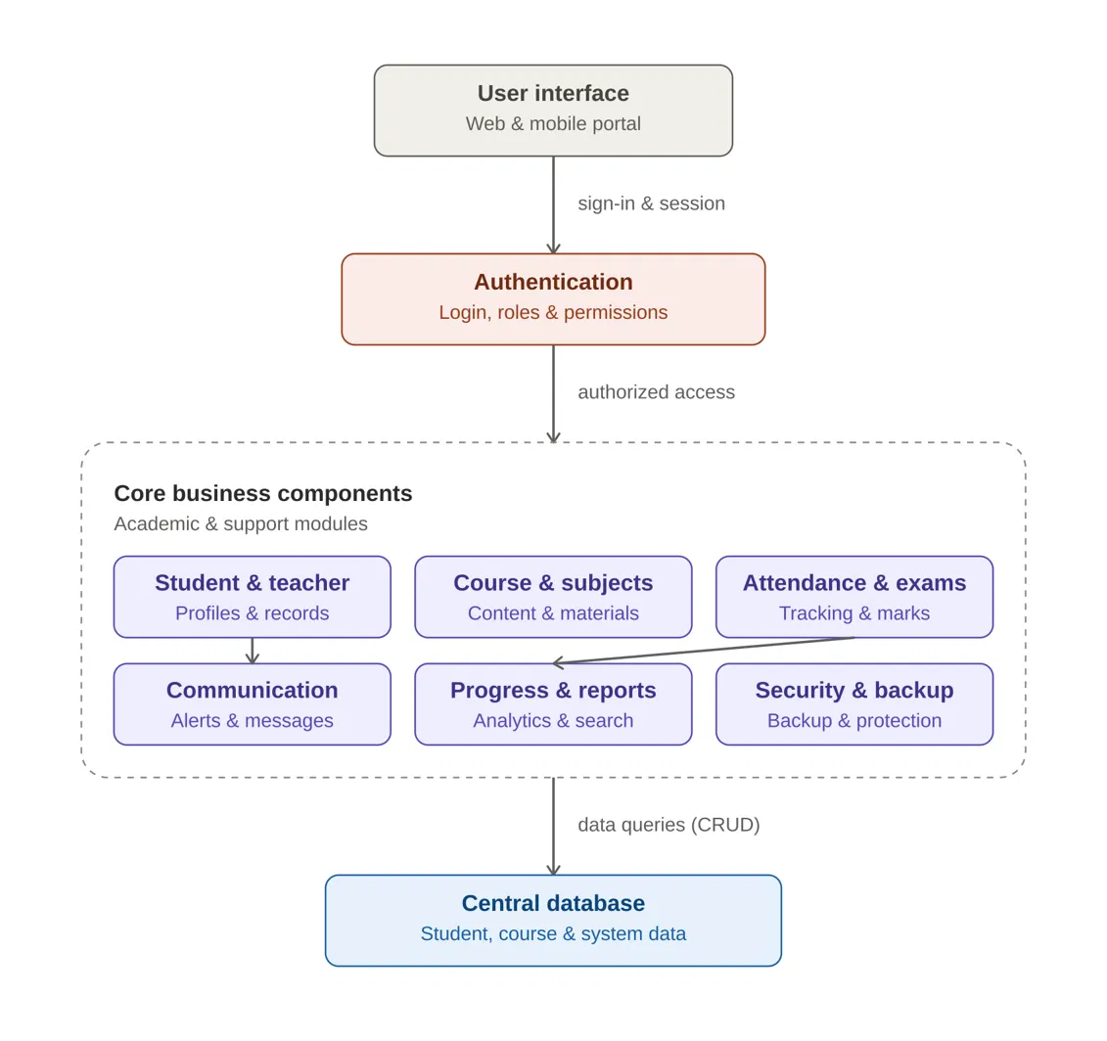

How I derived the components
Your document lists 12 functional requirements, from user registration to administrator functions. Rather than drawing 12 separate boxes (which would be unreadable), I grouped requirements that share data and purpose into 9 components, organized into 4 layers — a standard layered architecture for this kind of system:
Functional requirement(s) | Component it became
1. User Registration and Login | User interface + Authentication
2. Student Management | Student & teacher
3. Teacher Management | Student & teacher
4. Course and Subject Management | Course & subjects
7. Learning Material Access | Course & subjects
5. Attendance Tracking | Attendance & exams
6. Assessment and Grading | Attendance & exams
8. Communication Features | Communication
9. Progress Monitoring | Progress & reports
10. Search and Reporting | Progress & reports
11. Data Backup and Security | Security & backup
12. Administrator Functions | Authentication (roles/permissions)
How they're linked
- User interface → Authentication: every student, teacher, or admin first hits the UI, which hands off sign-in/session requests to Authentication. Nothing reaches the business logic without passing this gate.
- Authentication → Core business components: once a user is authorized, Authentication grants access into the whole business layer (the dashed container). This is why Authentication sits as its own layer rather than being buried inside one module — it's a cross-cutting concern every other component depends on, including the admin's ability to manage users and permissions (FR12).
- Inside the container, six peer components handle the academic work. They're grouped together because they all read and write the same kind of data and sit at the same architectural level — none of them depends on the others to function, but two interactions are worth calling out:
  - Student & teacher → Communication: the communication module needs the student/teacher contact list to send announcements and notifications (FR8 depends on FR2/FR3 data).
  - Attendance & exams → Progress & reports: progress monitoring and report generation (FR9/FR10) are built from attendance and grading data — they don't store their own copy, they aggregate from the Attendance & exams component.
  - Security & backup doesn't feed into the academic workflow directly; instead it sits alongside the other five and enforces data protection and backup policy across the whole layer and the database (FR11).
- Core business components → Central database: all six components ultimately persist and retrieve their data through one shared database (CRUD interface), rather than each maintaining its own store. This is what keeps student records, attendance, and grades consistent across modules — e.g. Attendance & exams and Progress & reports are reading the same underlying tables, not duplicated copies.

Prototype development

